**CSA0961-JAVA**

**PRACTICE- 4.1**

1. The formula for converting gallons to liters is: 1 US gallon = 3.785 liters. This program will convert a specific number of gallons (10) to liters and then display the output. The concepts in this practice will be explored in more detail throughout the course. Create a new project, package, and java class with a main method. Use the code below as a starting point and complete the code for the program. (Name your package galToLit and class GalToLit).

package galToLit; public class GalToLit {

public static void main(String[] args) {

// declare variables double gallons=10;

double liters=0; // add your calculation here //output the result to user System.out.println(gallons+" gallons equals "+liters+" liters"); } }

ANSWER:

package helloworld;

public class hellomain {

public static void main(String[] args) {

// declare variables double gallons = 10; double liters = 0;

// add your calculation here

liters = gallons * 3.785; // 1 US gallon = 3.785 liters

// output the result to user

System.***out***.println(gallons + " gallons equals " + liters + " liters");

}

}

OUTPUT :

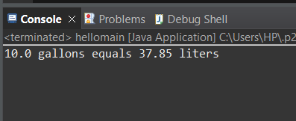

1. The Scanner class can be used to accept input from the user. Modify the code written in step 2 to prompt a user for the number of gallons to compute. To declare an instance of the Scanner class, use the code below: Scanner in = new Scanner(System.in); Your Java IDE may prompt you to import the java.util.Scanner package, or you can manually enter the import statement between the package name and the class declaration as shown below:

package galToLit; import java.util.Scanner; public class GalToLit {

To get a decimal value from the user, use the in.nextDouble() method and assign to the gallons variable.

ANSWER :

package helloworld;

import java.util.Scanner;

public class hellomain {

public static void main(String[] args) {

// Create a Scanner object to read input Scanner in = new Scanner(System.***in***);

// Declare variables double gallons = 0; double liters = 0;

// Prompt the user for the number of gallons System.***out***.print("Enter the number of gallons: ");

// Get the number of gallons from user input gallons = in.nextDouble();

// Perform the conversion

liters = gallons * 3.785; // 1 US gallon = 3.785 liters

// Output the result to the user

System.***out***.println(gallons + " gallons equals " + liters + " liters");

// Close the scanner in.close();

}

}

OUTPUT :

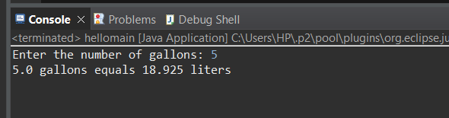

1. Describe three ways you can test the program that converts gallons to liters. TESTING THE ABOVE PROGRAM WITH DIFFERENT INPUTS :

# Example Inputs and Expected Outputs:

Input: 10 gallons

Expected Output: 10 gallons equals 37.85 liters

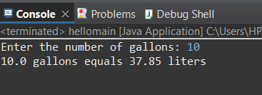

Input: 0 gallons

Expected Output: 0 gallons equals 0.0 liters

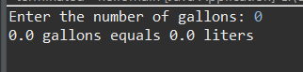

Input: 5.5 gallons

Expected Output: 5.5 gallons equals 20.8275 liters

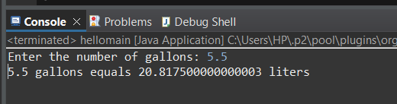

**Verification:** Compare the program’s output against the expected results to ensure accuracy. **Rationale:** This tests the core functionality of the conversion algorithm with a range of valid inputs. **Example Edge Cases:**

**Negative Input:** Input: -5 gallons

Expected Output: -5 gallons equals -18.925 liters (Verify the program handles negative values appropriately, or decide if negative inputs should be restricted.)

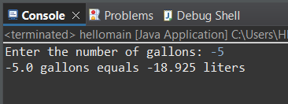

**Large Input:** Input: 1,000,000 gallons

Expected Output: 1,000,000 gallons equals 3,785,000 liters (Check if the program can handle very large numbers without performance issues or overflow.)

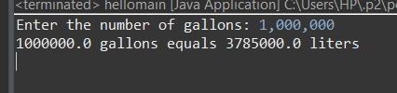

**Decimal Input:** Input: 0.1 gallons

Expected Output: 0.1 gallons equals 0.3785 liters (Ensure the program handles small decimal values accurately.)

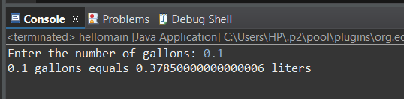

**Rationale:** Testing edge cases helps ensure the program is robust and behaves as expected in less common scenarios.

# Test for Invalid Inputs Example Invalid Inputs:

**Non-Numeric Input:** Input: abc

Expected Behavior: The program should either handle the error gracefully (e.g., with an error message) or prompt the user to enter a valid number.

